Claremont Bank Surgery

Online Patient Access Information Leaflet
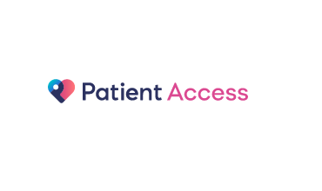
You can use Online Patient Access:
- Book appointments at the surgery
- Request repeat prescriptions
- View some of your Medical Record.
Being able to see your record online might help you to manage your medical conditions. It also means that you can even access it from anywhere in the world should you require medical treatment on holiday.

On handing in the Online registration form along with photo ID and proof of address you will be given your login details. When you login for the first time you will need to change your password so you will need to ensure you keep this safe so that only you are able to access your record.
It will be your responsibility to keep your login details and password safe and secure. If you know or suspect that your records have been accessed by someone without your consent then you should change your password immediately or contact the practice.

If you print any information from your record, it is also your responsibility to keep it secure. We recommend that you do not make copies at all.

THINGS TO CONSIDER:
- Forgotten history: there may be some things in your record you have forgotten.
- Choosing to share your information with someone: It’s up to you but also your choice to keep the information safe and secure.
- Misunderstood information: your medical record is designed to be used by clinical professionals. If you require clarification please contact the surgery.
- Information about someone else: If you spot something in the record that is not about you please log out immediately and contact the practice.

Guide to viewing your Medical Records:
Medications | You will be able to see all the repeat medications. If you want to request any repeat medication you will be able to do so through patient access.
Allergies / Adverse reactions | You will be able to see what allergies you suffer from and what if any adverse reactions you have had (i.e. to medication).
Immunisations | You will be able to see what immunisations/vaccinations you have had and the date which you had it.
Test Results | You will be able to see all your previous test results. You will not be able to view any results that are ‘provisional’; this means that the GP has not yet viewed the result and commented on it. If your GP has given you access to test results, you may see something that you find upsetting. This may occur before you have spoken to your doctor or while the surgery is closed and you cannot contact them.
Problems | You will be able to see any ‘problems’ and ‘conditions’. You will not be able to view any ‘free text’ within your medical record.
Misfiled information and/or Errors | All attempts are made to ensure your medical records are correct, however if you find any information which has been misfiled or find any errors, please contact the surgery as soon as possible.
Inappropriate use | We would consider inappropriate use not attending booked appointments, booking for other members using your name, consistently booking inappropriate appointments with members of our team; all of which will result in your access being removed.

